Passive (Tier 1)
Active (Tier 2)
Transformative
(Tier 3)
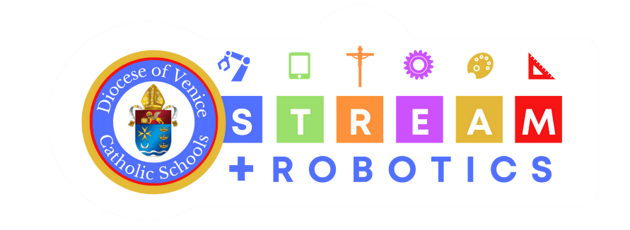

Technology Integration
Classroom Examples

Use the Technology Integration documents to help create a bullet list of examples in YOUR classroom of how you can integrate technology in the following tiers: passive (T1), active (T2), and Transformative (T3).

Grade: Subject: School:

