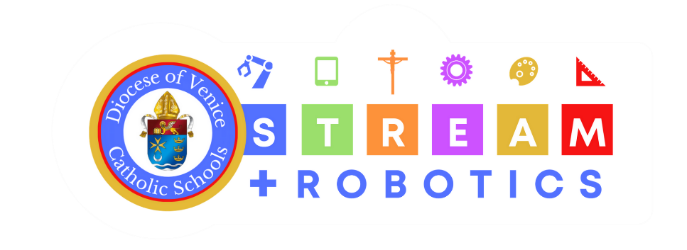

STREAM Project Outline

Teacher: _______________Sample Teacher______________________

Grade: (Circle / highlight) | PK3 PK4 K 1 2 3 4 5 6 7 8 9 10 11 12
Content Domain (Subject(s)):

Content Standards Addressed:
Faith Integration Standard(s) Addressed:
Gifts of CHRIST Addressed:
Truth, Beauty, Goodness, Affability, Humility, Prudence, Fortitude
Project Leaning Outcomes (what are the big concepts you want students to understand after completing the project)
2 or more Essential Questions/Driving Questions (at least one needs to have faith integration from faith standard or gift of CHRIST):

End Product Expectation (What will students create or complete?):

How can you tie in Science or Computer Science into your project?
Is your project relevant to a real world problem or could be applied to a real-world situation? How so?

How will technology be integrated into your project? What tier and what task?

What faith integration concept and or gift of CHRIST will you integrate into the project? How?

Will you use an engineering concept or the engineering design process?

How can you tie in Science or Computer Science into your project?

Is your project relevant to a real world problem or could be applied to a real-world situation? How so?

How will technology be integrated into your project? What tier and what task?

What faith integration concept and or gift of CHRIST will you integrate into the project? How?

How will you allow for student artistic expression or choice in the project?

Will you use an engineering concept or the engineering design process?
Break down the project expectations into the Engineering Design Process:
Ask:
Imagine:
Plan:
Create:
Test (or present):
Improve (reflection):

Breakdown of Knowledge (What do students need to know in order to answer the EQ and or DQ). This will also help you break down the project into digestible chunks or lessons leading up to the actual project.

